**Participant Information Sheet (PIS) – SUMMARY**

**TITLE:** A Clinical Study of Neflamapimod in Patients with Dementia with Lewy Bodies (DLB)

**PROTOCOL NO.:** EIP21-NFD-504

**SPONSOR:** EIP Pharma, Inc.

**Introduction**

Thank you for your interest in taking part in this clinical research study. Here is some initial information about the study and what it would mean if you decide to take part in it.

You are being asked to be in a research study because you have been diagnosed with Dementia with Lewy Bodies (DLB). It is up to you to decide if you want to be in the study. You can decide you do not want to be in the study, or you can leave the study at any time.

EIP Pharma (the sponsor) has developed a drug called neflamapimod that is being tested to see if it can help with your DLB symptoms. DLB symptoms can include problems with your memory, problems sleeping, hallucinations (seeing things that aren’t there), tremors (shaking of the hands, head, or another body part) and problems walking.

Neflamapimod is an “experimental” drug, which means it has not been approved by the Medicines and Healthcare products Regulatory Agency (MHRA) or by any other regulatory body, to be sold in the United Kingdom (UK) or in another country.

**About the Study**

This study will look at if whether neflamapimod can improve how you remember things and your concentration. The study will also look at your thinking ability and how good you are at being able to perform day-to-day tasks.

About 160 patients in the UK, the United States (US), and the Netherlands will be included in this study.

**160**

men and women aged 55 and older

**80**

participants will be assigned to take placebo

**80**

participants will be assigned to take neflamapimod

You will need to have a caregiver who is willing to participate in the study with you. The caregiver will attend all visits and will answer some questions about you and your health.

The placebo is a dummy drug that looks just like the real one, but does not have any active ingredients so does not cause any effect. To test neflamapimod, some participants are given placebo and the results are compared to see if one treatment works better than the other.

neflamapimod placebo

(example pictures, not actual sizes)

Whether you receive neflamapimod or placebo will be decided by chance (randomly) and nobody (the study doctors, other study staff, or your caregiver) will know which treatment you are taking unless it is required for a medical emergency.

In the study you will take a capsule, of neflamapimod or placebo, 3 times a day for 16 weeks (4 months):

**Dosing Schedule**, neflamapimod or placebo, daily, for 16 weeks (4 months):

 **Morning:** 1 capsule of study drug with breakfast or a snack

 **Midday:** 1 capsule of study drug with lunch or a snack

** Evening:** 1 capsule of study drug with dinner or a snack

**Study Visits**

If you decide to take part in the study, you will be asked to visit the clinic about 8-9 times over approximately 21 weeks (or 5 months), and you will be asked to come back for a follow-up visit 2 weeks after your last dose of study drug.

After you finish 16 weeks of treatment, you will be offered an opportunity to participate in an extension of the study where you will receive the real drug neflamapimod for 32 weeks (about 8 months) even if you took placebo in the 16-week treatment period.

**Screening Visit**

* Informed Consent
* Questionnaires to assess DLB
* Blood draws
* Questions about your health and medications
* Physical exam
* Vital signs
* Test of your heart (ECG)
* Brain scans (if required)
  + MRI (if you have not had one within the past 3 years)
  + DaTscan (if you have not had one within the past within 2 years)

*Eligible to participate in study?*

**YES**

Continue to Day 1

**NO**

No further visits

**Day 1**

* Assigned to study drug or placebo
* Questionnaires to assess DLB any DLB symptoms you have
* Blood draws (small blood samples)
* Questions about your health and medications
* Vital signs
* First dose of study drug
* Study drug dispensed to take home

**Day 14 (Week 2)**

* Blood draws (small blood samples)
* Questions about your health and medications
* Vital signs
* Study drug dispensed to take home

**Visits every 4 weeks**

**from Day 28 (Week 4) to Day 84 (Week 12)**

* Questionnaires to assess any DLB symptoms you have
* Blood draws (small blood samples)
* Questions about your health and medications
* Vital signs
* Study drug dispensed to take home

**Day 112 (Week 16)**

* Questionnaires to assess DLB any DLB symptoms you have
* Blood draws (small blood samples)
* Questions about your health and medications
* Physical exam
* Vital signs
* Brain scan (MRI)

*If you decide to continue to Extension Phase?*

**YES**

Continue to Day 1 of Extension Phase

**NO**

Continue to Follow-Up Visit (final visit)

**Telephone Call at Week 2**

**Visits every month (Week 4 and 8), then visits every 2 months (Weeks 16 and 32)**

* Questionnaires to assess any DLB symptoms you have
* Blood draws (small blood samples)
* Questions about your health and medications
* Vital signs
* Study drug dispensed to take home

**Risks**

In previous studies, neflamapimod has been given to about 323 participants, including about 150 patients that have dementia (either DLB or Alzheimer's Disease). Although not all side effects are known, the most common were:

* Headache
* Diarrhoea
* Falling
* Respiratory infection
* Sleepiness

Other risks and burdens of study participation include:

* Our tests which assess your memory and thinking abilities as well as our other assessments that may cause stress or fatigue.
* Blood samples will be drawn which can be uncomfortable or lead to bruising.
* The DaTscan test, if required, includes minimal exposure to radiation and the MRI scan can lead to feelings of claustrophobia. Every effort will be made to minimize your burden or risk throughout the course of the trial. Please see Appendix 1 for images of what DaTscan and MRI procedures look like.

It will not cost you anything, but you will not be paid for your participation in the trial. You may be reimbursed for travel fees. If you were to become sick or hurt from your participation in the trial, appropriate medical care will be given to you and the cost will be covered by the sponsor.

**What Happens to your Data during the Study?**

In this research study we will use information from you, including your medical records. We will only use information that we need for the research study. We will let very few people know your name or contact details, and only if they really need it for this study.

Everyone involved in this study will keep your data safe and secure. We will also follow all privacy rules.

At the end of the study, we will save some of the data in case we need to check it. We will make sure no one can work out who you are from the reports that are written.

**What if I have questions about the Study?**

If you are interested in learning more about the trial, the study staff can go over the Patient Information Sheet (PIS) with you. The PIS will provide more information about the study and what you will need to do to participate.

Thank you for reading this study summary and considering participation in this research study.

**Appendix 1: Images that represent brain scan procedures**

**DaTscan:** If you are required to have a DaTscan, below is an example of what you can expect during the procedure. Your facility may have a different DaTscan machine. Detailed information about the DaTscan is provided in the PIS.

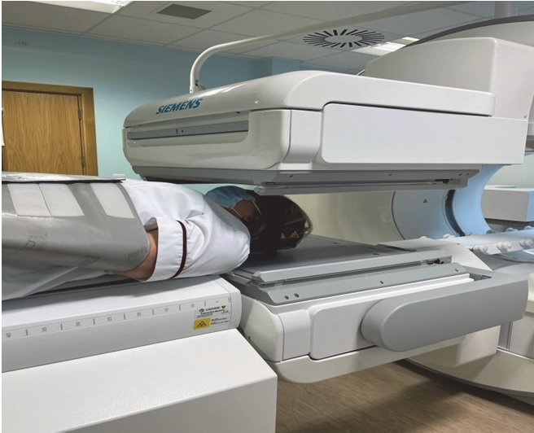

**MRI:** If you are required to have an MRI, below is an example of what you can expect during the procedure. Your facility may have a different MRI machine. Detailed information about the MRI is in the PIS.

